**SABITA PATRA**

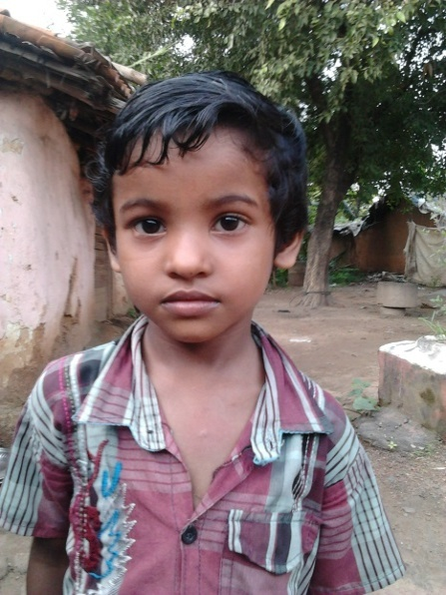

**PERSONAL DETAILS:**

* Class: I
* Gender: Female
* School: Gayatri Shiksha Niketan,

Adityapur

* Board of School: CBSE
* Medium of instruction: English

**DETAILS ABOUT FAMILY:**

* Father’s name: Debashish Patra
* Mother’s name: Jayanti Patra
* No of members in family: Four, one sister, mother and father
* Profession of father: Works in a bicycle repairing shop in Adityapur Industrial Area
* Profession of mother: Housewife

**FINANCIAL OVERVIEW:**

Monthly net income of household: Rs. 3000/-

**Total annual expenditure on education: Rs. 14,900/-**

Breakup of expenses

Tuition fees: Rs 500/- (per month) = Rs. 6000/- (per year)

Admission fees: Rs. 1850/- (per year)

Stationery: Rs. 3300 /- (per year)

Auto fare: Rs 300/-(per month)=Rs. 3600/-(per year)

**Average monthly expenditure on education: Rs. 1240/-**

**ENCLOSURES:**

1. Report Card of Class UKG (Previous class attended).

Report Card Page-1

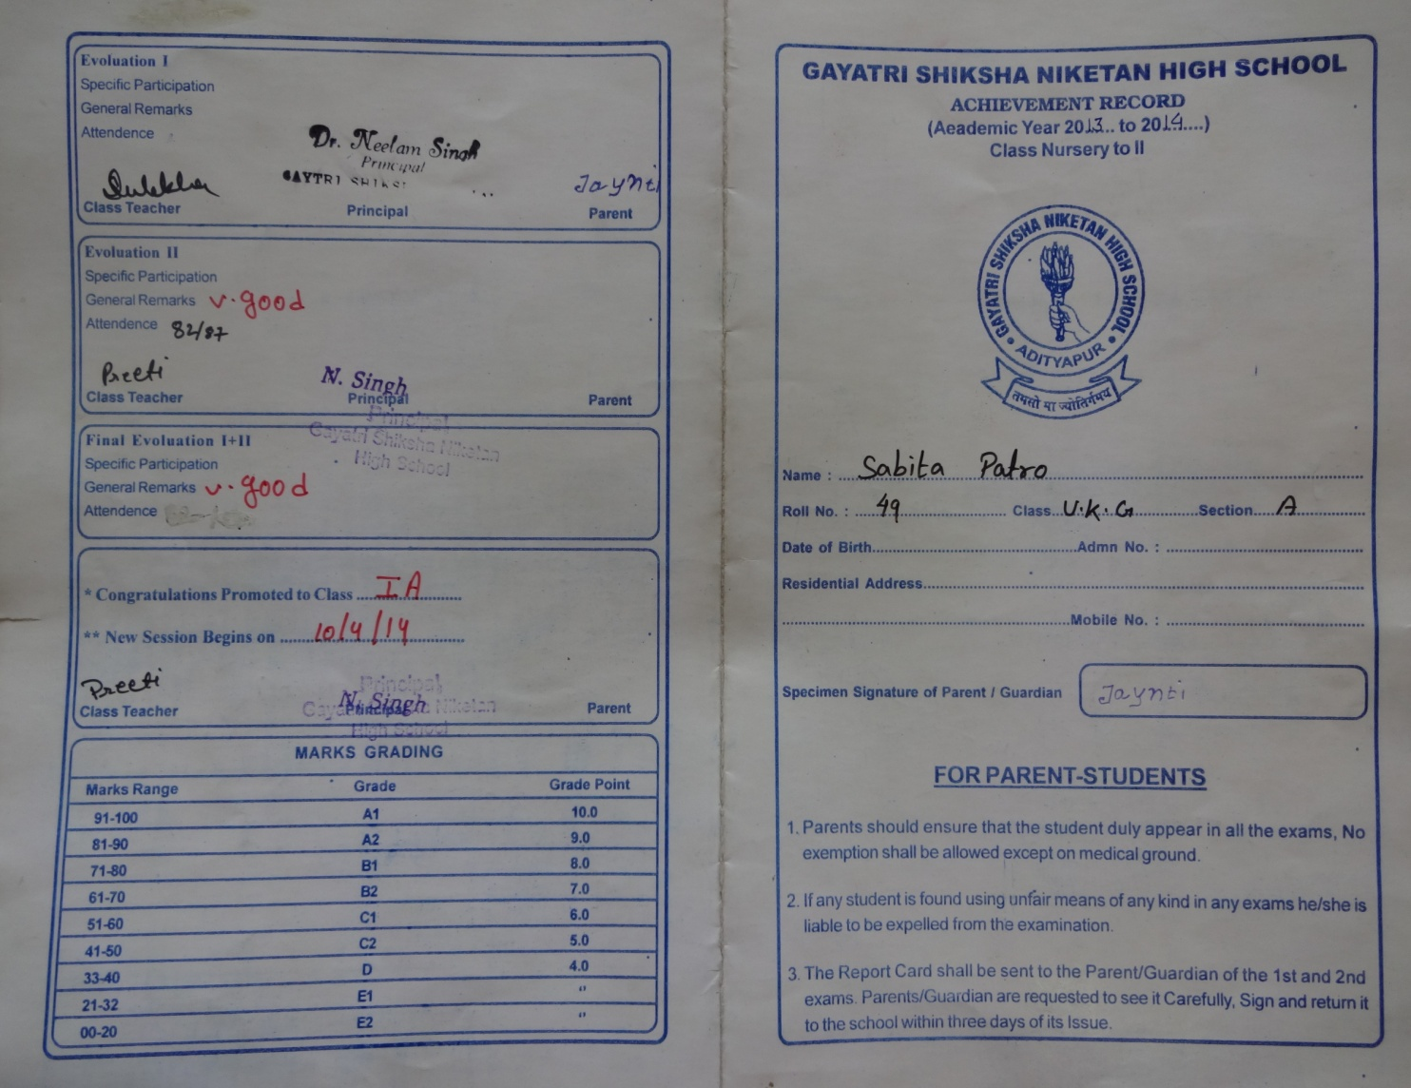

Report Card Page-2

